

**EUROPEAN UNIVERSITY OF LEFKE**

**FACULTY OF ENGINEERING**

**“Robot For Delivery”**

# 

# 

# 

# 

# 

# 

# 

# 

# 

# 

# 

# 

# 

# 

# 

# 

# **Interview Questions and Answers About Robot For Delivery**

Q1. Are the robot parts supposed to be designed by the development team?

A1. It can be bought, as well as designed by the development team whichever the team prefers.

Q2. Are we supposed to implement a Login interface?

A2. The robot doesn’t require any Login or Credentials.

Q3. Where is the robot supposed to drop off packages etc?

A3. Each department can have its own Baskets/Compartments for the packages and each compartment can have its own password and lock so that other people can not pick up the package.

Q4. Should there be tracking for the robot?

A4. The robot can have a tracking system. It should tell the user either it's being delivered or it has delivered the package to the user with an email or an SMS.

Q5. Should the robot also deliver the requested packages from 1 person to the other?

A5. The Robot cannot deliver for anyone but can only be used by the authorities of the university to the secretary and vice versa

Q6. Should there be a database?

A6. The robot itself doesn’t need an internal database but it should be able to send information to the cloud database it is programmed in and information about previous delivery can be accessed with the robot’s application.

Q7. What is the budget of this project?

A7. The budget of this project is $20000 excluding the robot.

Q8. How much development time do we have?

A8. Development Time given is 3 months.

Q9. Should the robot send information once or keep receiving?

A9. The robot should receive the information all the time.

Q10. Are there places the robot won’t be able to go?

A10. Yes, there will be restricted areas that the robot won’t be able to go to and robot should not be able to leave the university.

# **Operational Concept Design (OCD)**

**Company Description**

European University of Lefke (EUL) is an institution of higher learning, located in the Northern Cyprus Nicosia District town of Lefka, overlooking Morphou Bay. Founded in 1990 by Cyprus Science Foundation, the university opened in 1990 as a member of the Balkan Universities Network, and offers 84 undergraduate/associate programs and 37 postgraduate and doctoral degree programs which are approved by Turkey's Council of Higher Education (YÖK). The university campus is 45 minutes from the capital Nicosia, 60 minutes from Ercan Airport and the city of Kyrenia and 80 minutes from the city of Famagusta. The “philosophy” of the EUL is “science and education are universal in our age,” thus the EUL provides a broad range of contemporary education and is committed to maintaining international standards of excellence.

EUL is an international university with a multicultural population of students from 35 different countries and has distinguished and experienced academic staff from around the world. The medium of instruction is English. The primary mission of the EUL is to have a young generation equipped to become competent, self-confident, contemporary, creative and independent individuals who are able to cope with all the challenges of the global world, thus contributing to the development of the region and international community. It was founded in 1990 by Cyprus Science Foundation, the university opened in 1990 as a member of the Balkan Universities Network.

EUL has also signed agreements and memorandums of “understanding” with some of UK, USA, European, Asian, and Turkish universities. Besides international partnership with other universities, the University has also become a member of the various worldwide prestigious associations in the higher education sector. These offer students transfer opportunities to other international universities all over the world. The European University of Lefke also offers one of the most affordable tuition opportunities for international students.

## **Project Description**

At Eul, there is a need to deliver correspondence between different offices and postbox

Due to the regular transfer of correspondence between different offices and post boxes, the need arises to have a quick and efficient way to handle this task. Some problems that arise from manual solutions are the delivery of these packages to the wrong recipient which causes delay and worries to both the recipient and the sender, slow delivery which potentially decreases work efficiency of employees. The development of a robot which will have moving capability and will be able to transport multiple little packages will help curb this problem. It should be designed in a way that the recipient should be able to pick up the delivery using a password sent by the robot to the recipient.

When the robot gets to its destination, an email should be sent to notify the recipient so they can pick it up. Also, the robot should not leave the university.

**Organizational goals:**

|  |  |
| --- | --- |
| Goal Identifier | OG1 |
| Organizational goal | To provide high quality education |
| Description | The university aims to provide a world class educational experience for our students, by providing them with an up-to-date curriculum, cutting edge technology for practical purposes and all round excellent mentorship by the teaching staff |
| Measurable | This will be measured by the capabilities of our student at the end of the course study. |

|  |  |
| --- | --- |
| Goal Identifier | OG2 |
| Organizational goal | To train generations of competent professionals in different practices |
| Description | The university aims to produce graduates with the required skills to excel in their field of practice, thus creating a reputation for our institution. |
| Measurable | This will be measured by the quality of student project in student’s graduating year. |

|  |  |
| --- | --- |
| Goal Identifier | OG3 |
| Organizational goal | To provide our students with experience instructors in their field of expertise. |
| Description | The university aims to provide a world class educational experience for our students, by employing highly accredited professors competent in their field and skilled at passing on information to students. |
| Measurable | This will be measured by student feedback from our yearly institutional surveys. |

|  |  |
| --- | --- |
| Goal Identifier | OG4 |
| Organizational goal | To produce students with innovative thinking |
| Description | The university aims to graduate sets of students who are skilled at creating practical solution and highly innovative.. The university aims to achieve this by providing the students access to lab equipment for innovative practices. |
| Measurable | This will be measured by students' ability to produce innovative solutions to problems. |

|  |  |
| --- | --- |
| Goal Identifier | OG5 |
| Organizational goal | To provide effective administrative services for our students |
| Description | The university aims to provide professional and efficient administrative services when processing our students into the universities system. We also aim to provide a stress-free registration process for students |
| Measurable | This will be measured by student feedback from our yearly institutional surveys. |

|  |  |
| --- | --- |
| Goal Identifier | OG6 |
| Organizational goal | To integrate innovative technology into the university’s eco-system |
| Description | The university aims to improve both work experience(for our staff), and learning experience(for our students) by introducing new and innovative technology as often and quickly as possible so as to boost efficiency for both our academic and non-academic staff and also to create a modern learning environment for our students. |
| Measurable | This will be measured by the amount of new technology that has been introduced and previously manual processes that have now been automated. |

|  |  |
| --- | --- |
| Goal Identifier | OG7 |
| Organizational goal | To provide effective inter-faculties communication |
| Description | The university aims to ensure clear communication between different faculties and from the rectorate to other faculties. |
| Measurable | This will be measured by the increased  productivity and reduced error in transmission of information in the university |

## **Key Stakeholders**

Vendor/Project sponsor

|  |  |
| --- | --- |
| Name | Mr. Rand Paul |
| Phone No | +90 545 887 1018 |
| Email address | indigocorp@icp.tr |

Client

|  |  |
| --- | --- |
| Name | European University of Lefke |
| Phone No | +90 777 089 4279 |
| Email address | admin@eul.edu.tr |

User Contacts

|  |  |
| --- | --- |
| Name | Versile Evrim |
| Phone No | +90 679 347 1918 |
| Email address | vevrim@eul.edu.tr |

|  |  |
| --- | --- |
| Name | Cem Kalyoncu |
| Phone No | +90 529 387 2230 |
| Email address | cekalyu@eul.edu.tr |

|  |  |
| --- | --- |
| Name | Ezgi Ulker |
| Phone No | +90 675 667 9073 |
| Email address | eulker@eul.edu.tr |

Developers

Project Manager:

|  |  |
| --- | --- |
| Name | Sertuğ Kaptan |
| Phone No | +90 923 887 4329 |
| Email address | sergkap23@gmail.com |

Head Engineer:

|  |  |
| --- | --- |
| Name | Adak Rakhimzhanov |
| Phone No | +90 445 721 0078 |
| Email address | arakhim00@gmail.com |

Product Designer/UIUX Designer:

|  |  |
| --- | --- |
| Name | David Nwanze |
| Phone No | +90 443 765 0021 |
| Email address | dawaze60@gmail.com |

Full-Stack Developer:

|  |  |
| --- | --- |
| Name | Moshin Khan |
| Phone No | +90 876 554 9021 |
| Email address | mosh56@gmail.com |

QA Engineer/Tester:

|  |  |
| --- | --- |
| Name | Yasir Akram |
| Phone No | +90 077 665 7648 |
| Email address | yakram99@gmail.com |

Hardware Suppliers

|  |  |
| --- | --- |
| Name | Falcon Tech. Solutions |
| Phone No | +90 556 009 4000 |
| Email address | homedesk@faltech.org |

|  |  |
| --- | --- |
| Name | Contra Solutions |
| Phone No | +90 500 106 0000 |
| Email address | homedesk@consolut.org |

|  |  |
| --- | --- |
| Name | Stensen Group of Companies |
| Phone No | +90 690 007 1000 |
| Email address | homedesk@stensen.org |

Maintenance Team

|  |  |
| --- | --- |
| Name | Ace Tech. Incorporated |
| Phone No | +90 436 779 8809 |
| Email address | homedesk@setmain.org |

## **System Boundary /Environment (Context Diagram)**

This system context diagram will define the boundary between the system, or parts of a system, and its environment, showing the entities that it interacts with. This diagram, sometimes called a data flow diagram, is required to give information about actions that external entities will perform on the system or action the system will perform for said external entities. It also shows the system’s interactions with already in-place systems.

## **Project Goals:**

|  |  |
| --- | --- |
| Goal identifier | PG-1 |
| Project Goal | To create an efficient automated delivery system |
| Description | This project aim to develop a system of robots capable of delivering mail and other packages for the university’s staff, this process is currently done manually and will be automated with the help of this system |
| Measurable | This goal is measured by how good the system is at delivery compared to the prior manual system that was in place |
| Relevance | OG5, OG6, OG7 |

|  |  |
| --- | --- |
| Goal identifier | PG-2 |
| Project Goal | To minimize human error |
| Description | This project aim to reduce human error in the mail delivery process by automating the process. By letting computers manage the delivery, human errors will be significantly reduced |
| Measurable | This goal is measured by how many packages were successfully delivered to the correct recipient |
| Relevance | OG5, OG6, OG7 |

|  |  |
| --- | --- |
| Goal identifier | PG-3 |
| Project Goal | To increase efficiency in the organization |
| Description | With the automation of the delivery process in the organization , by reducing the time it for deliveries to be completed. As robots do not get tired like humans do productivity between the organization’s offices will be boosted due to increased speed of mail delivery |
| Measurable | This goal is measured by how fast offices get their mail compared to the prior manual method. |
| Relevance | OG5, OG7 |

|  |  |
| --- | --- |
| Goal identifier | PG-4 |
| Project Goal | To reduce long term cost of operations |
| Description | Some university staffers hire their personal delivery agents which can be costly in the long run, with the implementation of this system in the university’s eco-system, this cost is removed. |
| Measurable | This goal is measured by the absence or reduced number of personal delivery agents working on campus |
| Relevance | OG5, OG6, OG7 |

|  |  |
| --- | --- |
| Goal identifier | PG-5 |
| Project Goal | To boost investor interest |
| Description | With the introduction of a technological approach to the mail delivery system, investors will feel obliged to sponsor more projects as its obvious the effect of their investments |
| Measurable | This goal is measured by increased donations to the university board |
| Relevance | OG1,OG2(With increased funding, better teachers can be hired) |

|  |  |
| --- | --- |
| Goal identifier | PG-6 |
| Project Goal | To increase security in the delivery system |
| Description | There have been some cases of packages and mails getting to the wrong recipient, this is extremely bad in cases of confidential documents. The system is designed in such a way that there is an authentication process to verify if the recipient of any package is the correct individual. |
| Measurable | This goal is measured by reduced cases of mix-ups in package deliveries and user feedback. |
| Relevance | OG5, OG7 |

# **System Software Requirement Document (SSRD):**

* **Camera**:

The system should have a camera to analyze delivery packages and observe the surroundings. With the help of Camera, the robot will be able to recognize its destination.

* **Source of supply:**

The system should have efficient source of supply. source of supply is the main part in robot with the help of which robot moves.

* **Scanner:**

The system should have a scanner which reads the bar code or serial numbers on the packages. With the help of scanner robot will recognize the package and delivered it to the exact location

* **Map:**

The system should have proper map memory of the campus in order to execute proper operation. Map will be used by the robot for navigation

* **GPS:**

The system will use GPS to send information to the sender for tracking the robot and information about the location of the basket.

* **User Friendly:**

The system should be user friendly.

* **Security System:**

The security system must be solidly built because of chances that the files being moved could contain confidential or important information.

# **DEVELOPMENT REQUIREMENTS:**

## **Budget Requirements:**

The system’s budget, given by the client for development, is 20000$. Excluding the robot’s cost which will be bought instead of being developed. Buying the robot will reduce development costs and the development time.

## **Time Requirements:**

The system is given 3 months to be developed and finished by the client.

## **Language Requirements:**

The web application for the system will require the use of the following languages:​

* Python/Html: For making CSS and JS come together and make the web page​
* CSS: For the design of the webpage​
* JavaScript: For the interactions of the webpage​
* MySQL: For design of the databaseMySQL: For design of the database​​
* C/C++ : For programming of the Robot

## **Hardware Requirements:**

The hardware required for this project are :

**Sensor:** To detect objects/obstacles during navigation.

**GPS:** For tracking the location of the robot as well as understanding the location of the baskets.  
**Robot:** For delivery of the packages and shipments.

**Camera:** So that our robot can recognize where it is going.

**Baskets:** For holding the packages to be delivered.For our packages to be delivered in.

**Locks:** For locking our baskets so nobody can take the package from the baskets other than the person who ordered.

**Servers:** For the user to connect and for the robot to keep on communicating with.

**STANDARDS COMPLIANCE REQUIREMENTS**:The system object broker capabilities shall comply with the OMG OCL (Object Constraints Language) standard as it uses C, C++ and Python.

**DEPLOYMENT REQUIREMENTS:**

* The sensor should be tested thoroughly to make sure it can detect obstacles.
* The gps system should be set up and connected to the server.
* The email system should be set up in the robot’s application so the sender and receiver whose details were entered can receive an email.
* **SUPPORT ENVIRONMENT REQUIREMENTS:**

- The delivery system is supported by environments that are language-centered and method-based.- The language-centered environment provides a tool set suited to the python as well as C and C++ languages used in the project.  
-The method-based environments provide a broad range of activities for the software development process.  
-This environment also incorporates tools required for a particular specification and design methods.  
-The required support personnel should have good communication skills, should be able to do testing and he should understand the end user perspective.

**Capability requirements for the proposed system:**-The system should be able to notify both the sender and receiver if the package has been delivered or if it is still in transit by a tracking system.  
-The system should be able to send a notification through an email when the robot has delivered the package

-The Robot should be able open the baskets that are locked and put the package inside of these baskets   
-The Robot should be able to go from one department to the other one.

**System requirements:**  
• The robot should have a camera to recognize baskets  
• The robot’s system should be user-friendly.  
• This robot should have a Storage place to store all the shipments.  
• The robot should be tracked.   
• There should be a webpage to show if the delivery has completed or not

• The robot should have legs to go to a different part of the organization or department

**System interface requirements:**The system interface should have a form where the sender can input the details of him/herself(sender), recipient and the product information. It should also have an interface where the sender can indicate if the delivery has completed.

A web page will also be present which will receive information from the robot GPS system to display if the robot has delivered the goods to the destination.

**Graphical user interface standards:**

* Homepage should have a Login button and form where the sender can enter ID and password.
* Homepage should have a “send package” button and when clicked should open up a form where the sender, receiver and package details can be entered.

**Hardware interface requirements:**  
• The system should have a camera that will scan the number on the basket to know if it’s the correct basket**.**• The system should be able to tell the robot where to navigate.  
• The system should be able to be transported and easy to be carried, i.e it shouldn’t weigh extravagantly much.

•The robot should be able to lift up heavy objects for transportation

•The robot should be able to connect to servers.

**Communication interface requirements:**• First a wireless interface system.  
• A GPS, so that the robot can communicate with the servers where they are.

•The robot should keep communicating with the servers in case the target basket changes or it gets lost/stolen.  
• The robot should have an intelligent camera system that can recognize baskets and the numbers on top of it to put the package into the right basket and then communicate with the system to send an email.  
• A system for the robot and the software to communicate to send an email.

**DESIGN DOCUMENTATION**

* **SCENARIO**

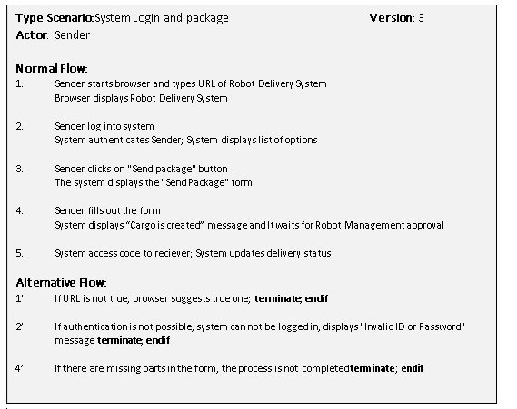

* **USE CASE DIAGRAM**

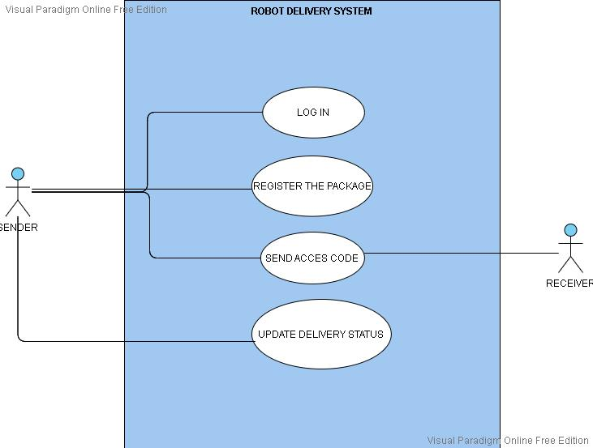

* **CONTEXT DIAGRAM**

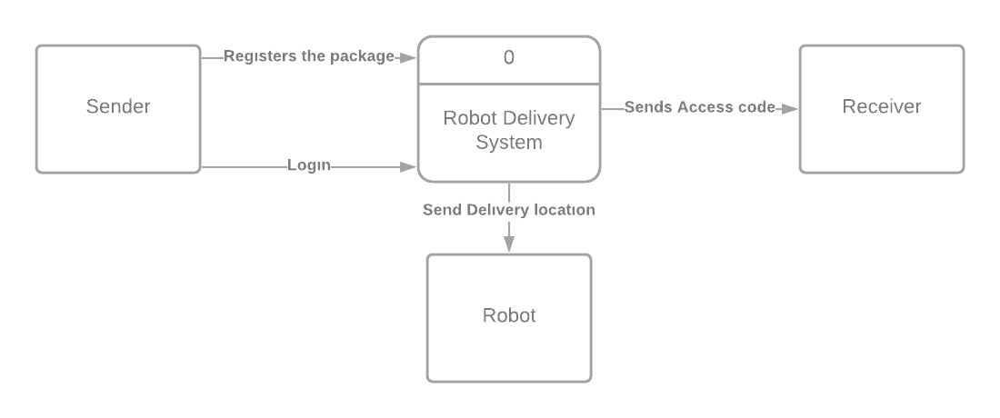

* **DATA FLOW DIAGRAM**

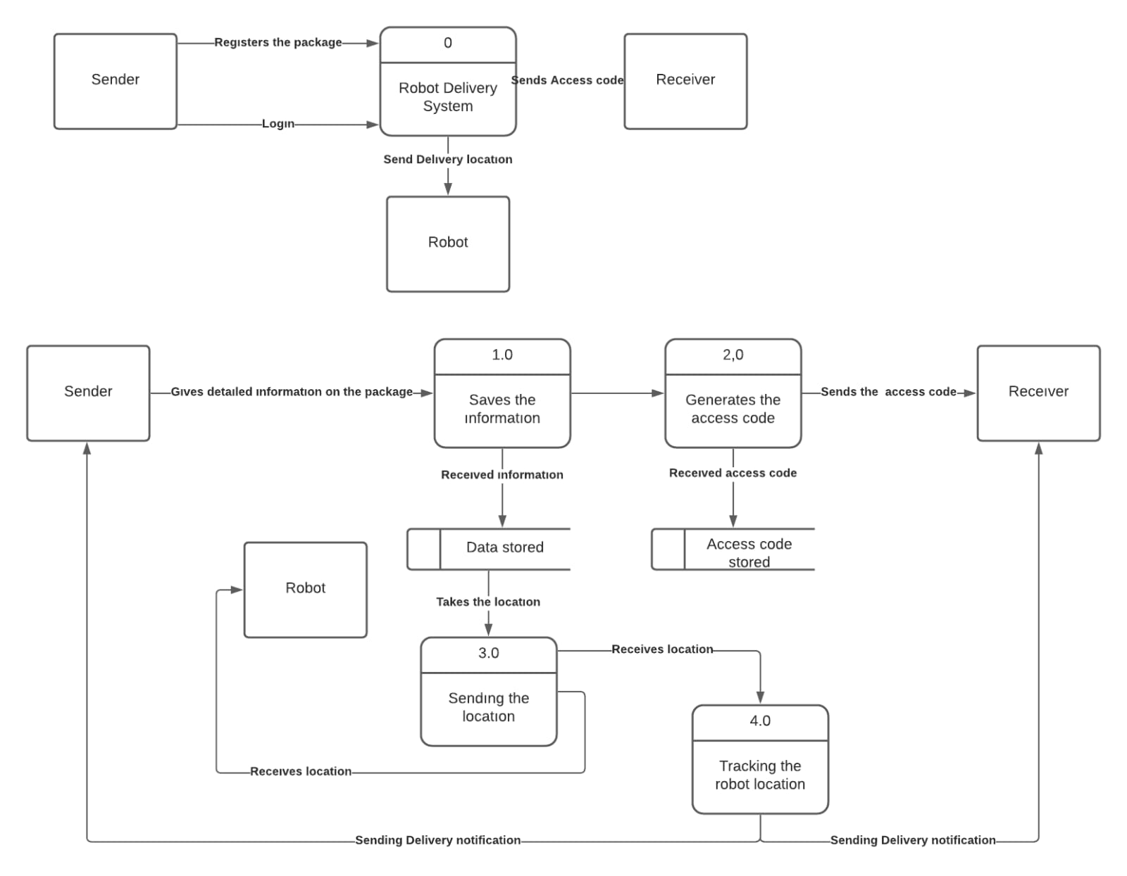

* **SEQUENCE DIAGRAMS**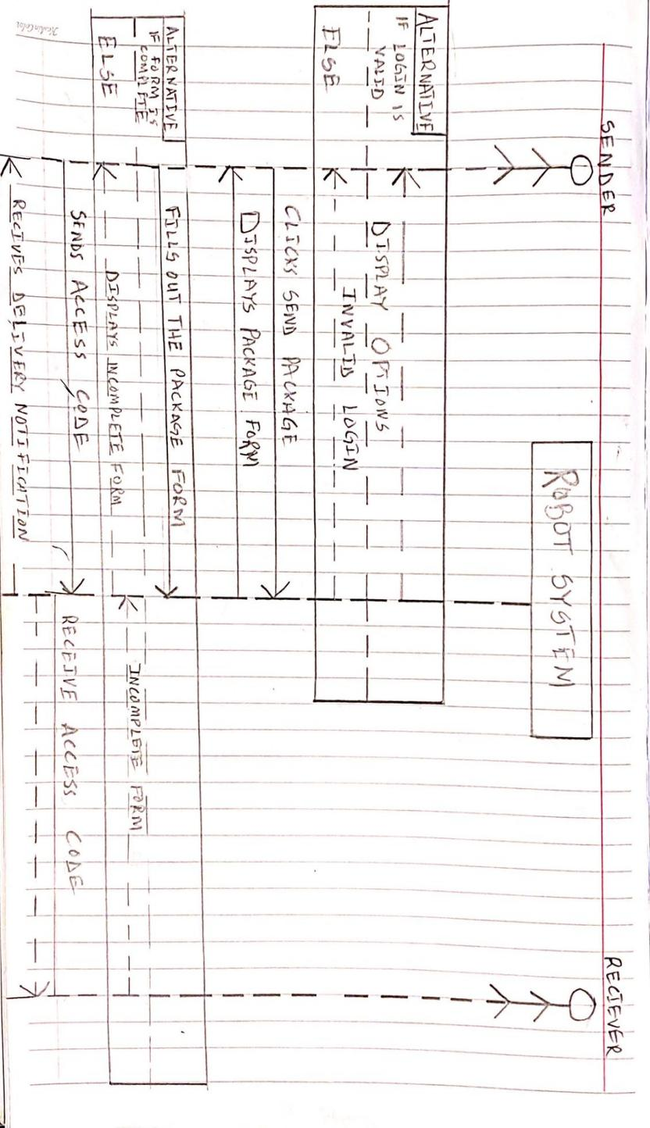

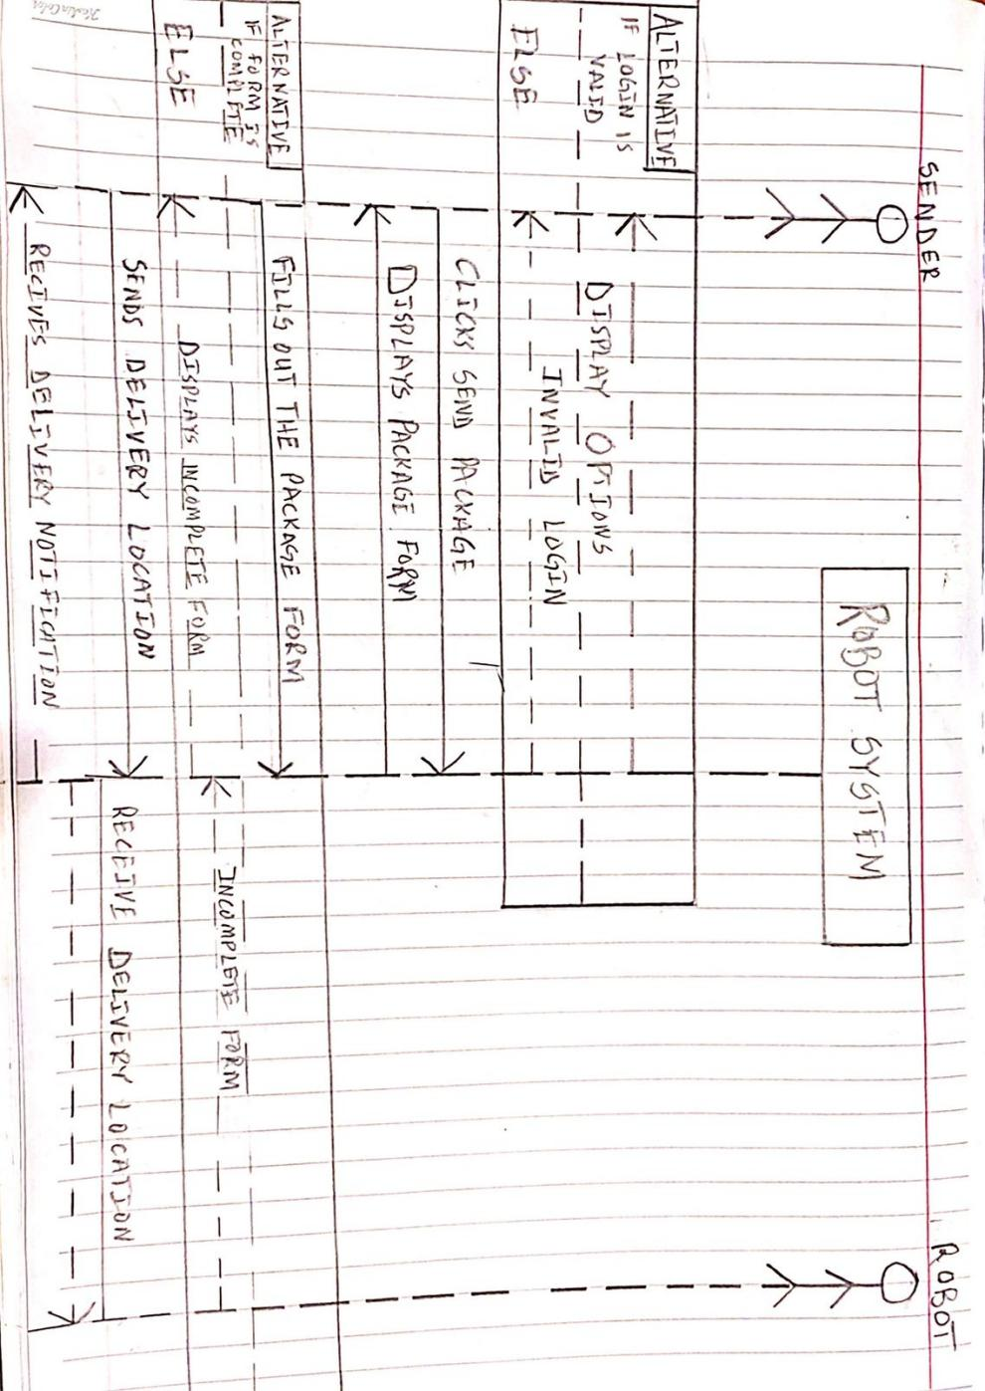

* **ARCHITECTURAL STYLE**

The system uses the implicit invocation architectural style. This can be seen in the way it transfers information to the actors of the system. When a sender enters delivery information, it triggers function calls in the system which takes the location entered and sends it to the robot GPS system, it sends an email to the recipient of the package and does not care what is done with that information.

* **INTERFACE DESIGN**

